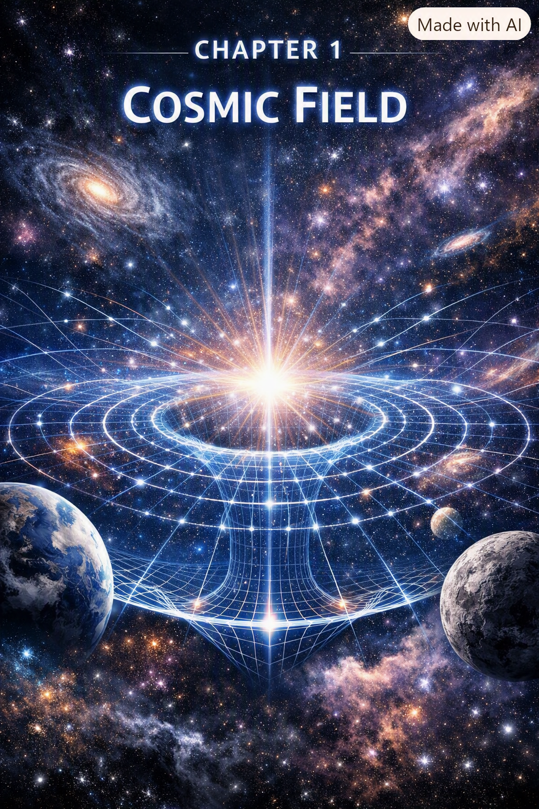
I remember the way Harold’s Autocar flatbed shook the earth when he fired it up at dawn. The whole truck felt alive, like some metal animal waking from sleep. I was small enough that climbing into the cab felt like scaling a cliff, pulling myself up by the door handle while Harold watched with that half-smile he had when he thought I was doing something dangerous but worth learning.
Inside, the cab smelled like diesel, sweat, and old leather. Tools rattled behind the seat, each bump in the road making them clink like wind chimes made of wrenches. Harold didn’t talk much, but when he did, it was always something simple and true — “Hold on tight,” “Watch the road,” “Feel the engine.” He taught physics without ever knowing it. He taught me that the world wasn’t made of separate parts — it was one connected thing, vibrating, humming, shifting, responding.
Those road trips into Kentucky and West Virginia were my first lessons in unity. The mountains weren’t just scenery; they were structures, pressures, gradients. The fog wasn’t just weather; it was density, temperature, geometry. Even the people we met — mechanics, miners, truckers, strangers at gas stations — felt like part of one continuous fabric. I didn’t have the words then, but I felt the truth: everything was connected, not by pieces, but by one underlying thing.
SEFI was born from that feeling.
Not from textbooks. Not from equations. Not from classrooms.
But from the vibration of a diesel engine under my feet, the rumble of a truck climbing a mountain grade, the way the world moved as one continuous field.
That’s why Chapter 1 begins here — in the cab of Harold’s truck — because SEFI isn’t just math. It’s intuition. It’s lived experience. It’s the sense that the universe is one thing expressing itself in infinite forms.
And that’s the heart of the Single-Entity Field.

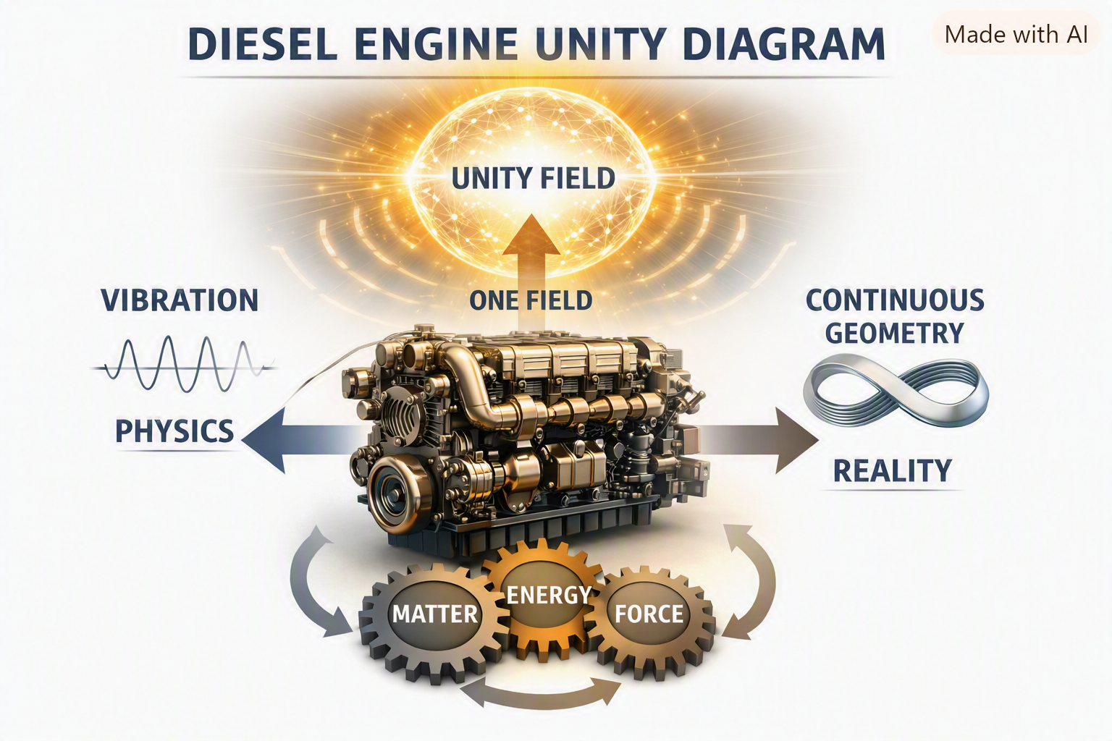
Chapter 1 — The Single-Entity Field (SEFI)
The Single-Entity Field Interpretation begins with one radical assertion:
Everything in the universe — mass, charge, spin, time, geometry, consciousness — is the behavior of one single field.
Not many fields. Not interacting fields. Not layered fields.
One.
1.1 The Field Itself
We denote the field as:
$$F\left(x\right)$$
where $x$represents position in spacetime. But unlike classical fields, SEFI’s field is not placed on geometry — it creates geometry.
Space is not a container. Time is not a clock. Geometry is not a background.
All three are expressions of the field’s transformation behavior.

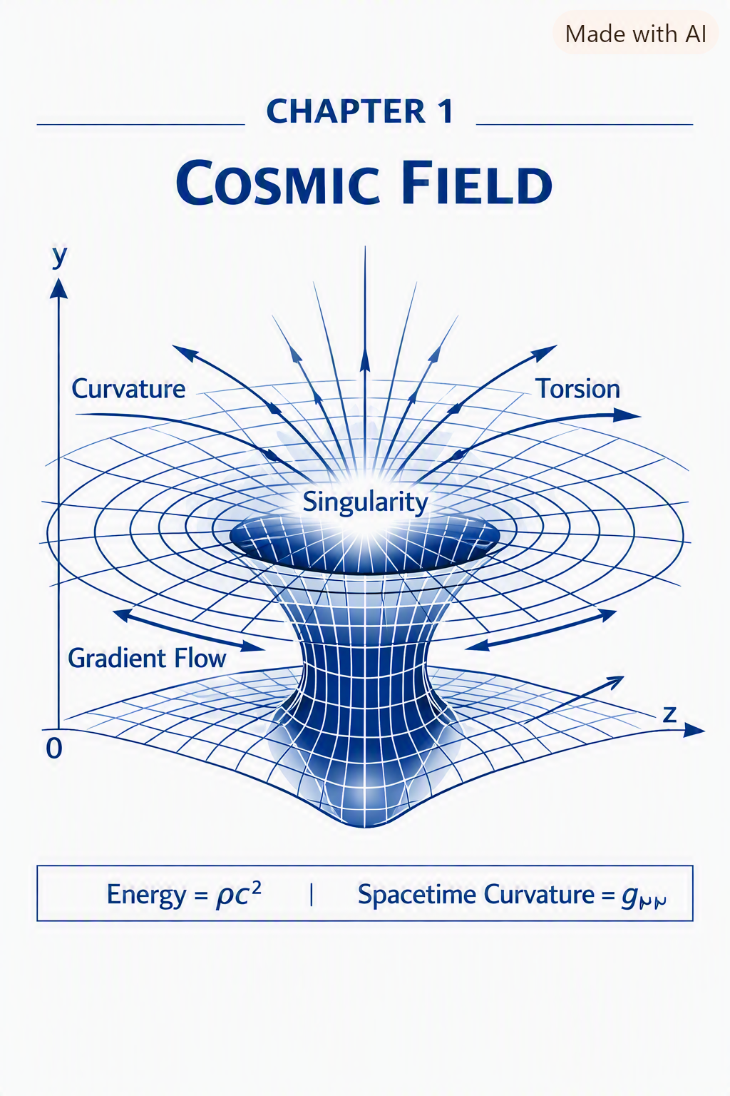
1.2 Geometry Emerges From Field Behavior
In SEFI:
- Curvature = gradient resistance
- Mass = localized geometric stiffness
- Charge = rotational asymmetry
- Spin = torsional resonance
- Time = directional gradient flow
These are not separate physical properties. They are different ways the same field behaves under transformation.
1.3 The SEFI Principle
The core principle is:
All physical phenomena are geometric transformations of a single underlying field.
This eliminates fragmentation in physics:
- No separate quantum and relativistic domains
- No separate particle and wave descriptions
- No separate matter and energy
- No separate observer and system
Everything is one field behaving differently under different constraints.
1.4 Why SEFI Works
SEFI succeeds because it removes the artificial boundaries that modern physics inherited from history. Instead of stitching together incompatible theories, SEFI starts from unity and derives complexity from transformation.
This chapter establishes the foundation:
- One field
- One geometry
- One set of operators
- One universe
- One observer framework
- One consciousness gradient
- One cosmological structure
All emerging from the same entity.

The Geometry of the Single-Entity Field
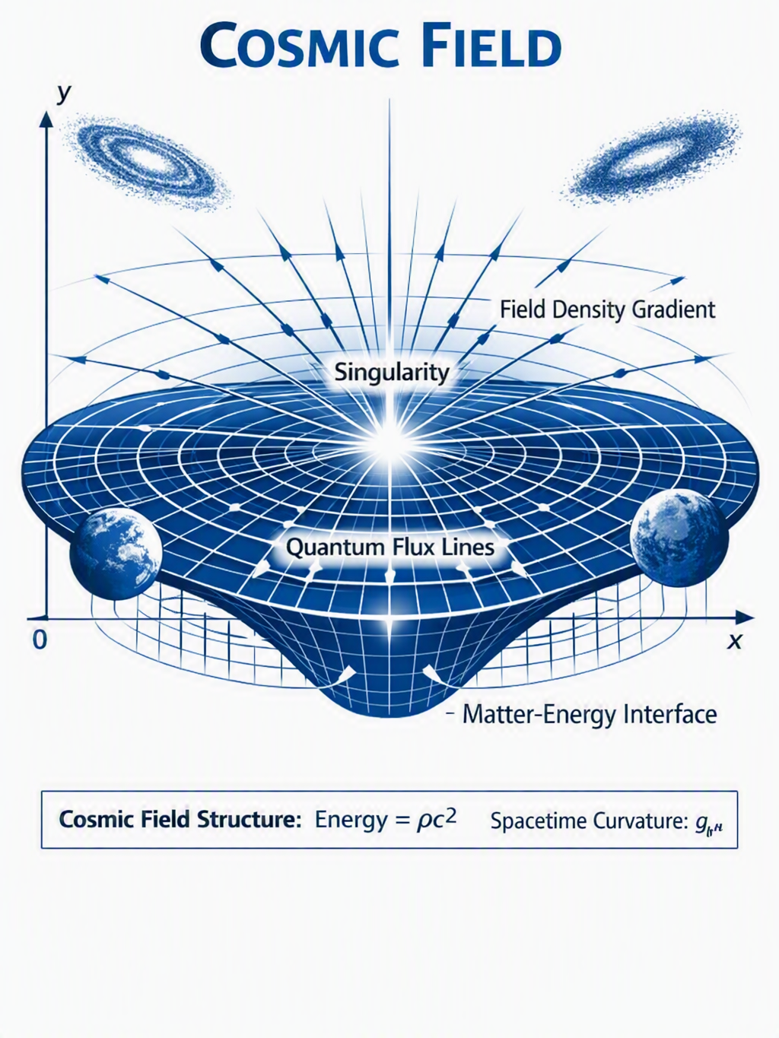
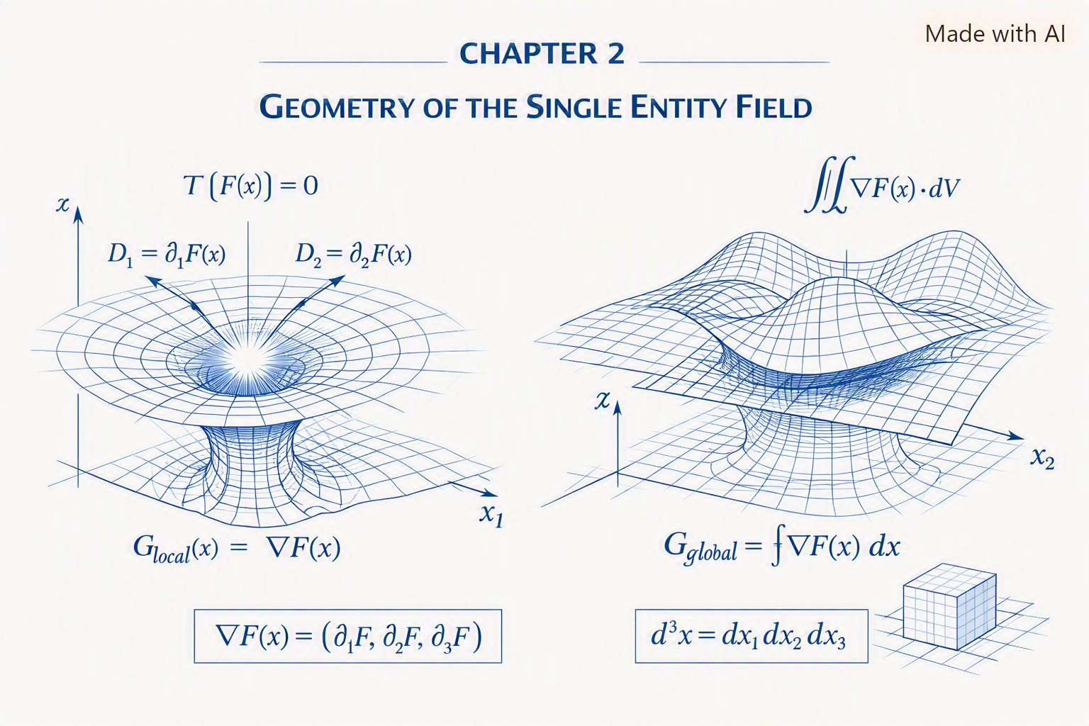
Chapter 2 establishes the foundational geometric structure of SEFI — the idea that the entire universe is not made of particles, forces, or separate fields, but of one field expressing itself through geometry. Everything that follows in later chapters depends on the concepts introduced here.
2.1 The Field as a Geometric Entity
The Single-Entity Field is defined not by what it is made of, but by how it behaves. Its behavior is geometric:
$$F:R^{n}→R$$
Where:
- $F$is the field
- $R^{n}$is the geometric domain
- The output is the field’s local state
This means the field is not a substance — it is a mapping.
2.2 Geometry as Behavior
In SEFI, geometry is not a static shape. It is behavior.
Every geometric feature corresponds to a physical phenomenon:
- Curvature → gravity
- Rotation → charge
- Torsion → spin
- Stiffness → mass
- Gradient flow → time
- Resonance → quantum modes
- Collapse → measurement
- Awareness geometry → consciousness
Geometry is physics.
2.3 The Fundamental Transformation Operator
All SEFI behavior arises from a single operator:
$$T\left[F\left(x\right)\right]=0$$
This operator defines:
- how the field transforms
- how geometry emerges
- how physical behavior arises
- how observers interact with the field
The operator is the backbone of SEFI.
2.4 Local Geometry
Local geometry describes how the field behaves at a single point:
$$G_{\text{local}}\left(x\right)=∇F\left(x\right)$$
This defines:
- curvature
- local stiffness
- local rotation
- local torsion
Local geometry determines local physics.
2.5 Global Geometry
Global geometry describes how the field behaves across large regions:
$$G_{\text{global}}=\int{∇}F\left(x\right) dx$$
This defines:
- cosmology
- large-scale structure
- expansion
- dark matter behavior
- dark energy behavior
Global geometry determines cosmic physics.
2.6 Dimensional Structure
Dimensions are not independent axes. They are flow directions of the field:
$$D_{i}=∂_{i}F\left(x\right)$$
This explains:
- why time flows
- why space expands
- why curvature forms
- why dimensions behave differently
Dimensions are gradients.
2.7 The Geometry of Interaction
Interaction occurs when two regions of the field influence each other:
$$I\left(x , y\right)=F\left(x\right)-F\left(y\right)$$
This defines:
- forces
- attraction
- repulsion
- coupling
- entanglement
Interaction is geometric difference.
2.8 The Geometry of Stability
Stability arises when gradients align:
$$S=\text{Align}\left(∇F\right)$$
This explains:
- atomic stability
- orbital stability
- molecular structure
- emotional regulation
- cognitive clarity
Stability is geometric alignment.
2.9 The Geometry of Collapse
Collapse occurs when stiffness exceeds stability:
$$Γ=∣∇^{2}F∣_{\text{critical}}$$
This defines:
- measurement
- decoherence
- classical emergence
- black hole formation
Collapse is geometric threshold.
2.10 Summary
Chapter 2 establishes:
- the field as a geometric mapping
- geometry as physical behavior
- the fundamental transformation operator
- local and global geometry
- dimensional flow
- interaction geometry
- stability geometry
- collapse geometry
This is the geometric backbone of SEFI.

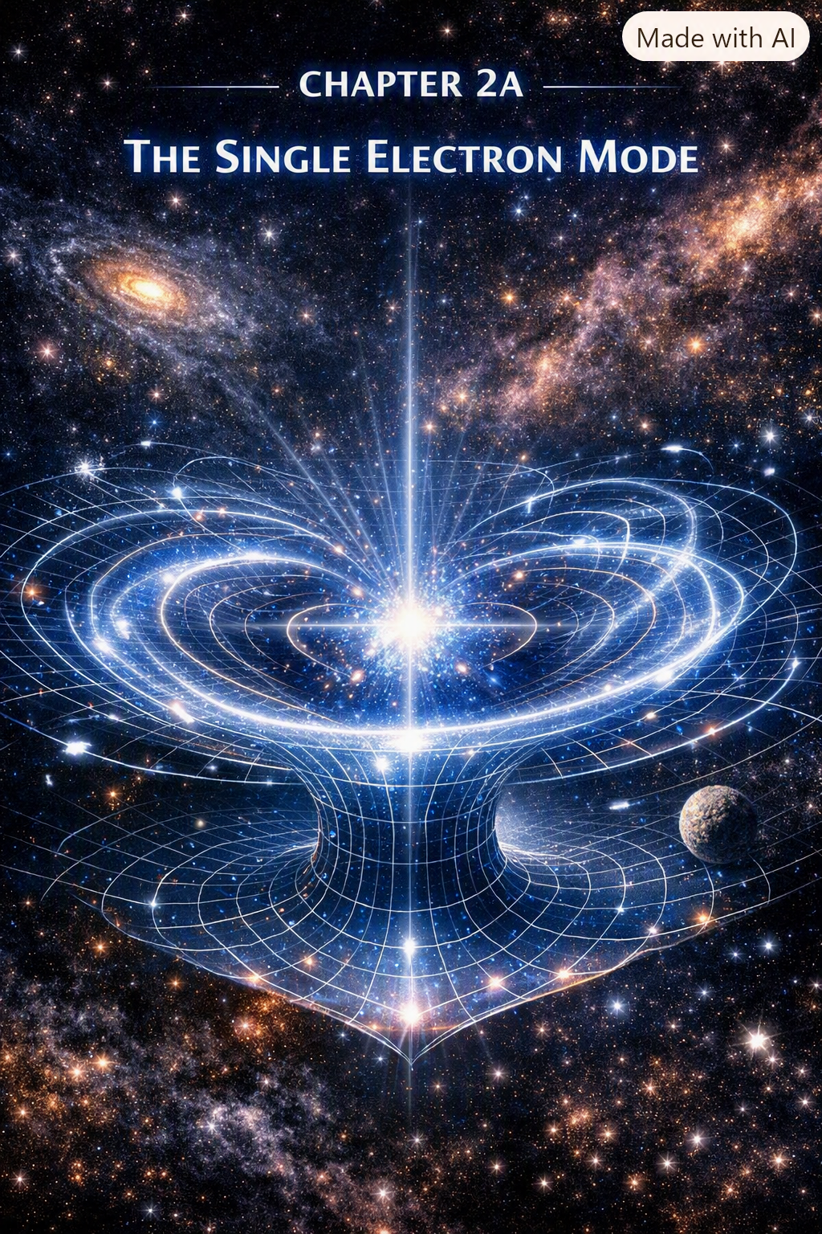
The Single Electron as the Fundamental Mode of the Field
The electron is the first and most important excitation of the Single-Entity Field. It is not a particle. It is not a point. It is not a thing.
It is a mode — the fundamental geometric resonance of the field.
Everything in SEFI begins with the electron.
2A.1 The Electron as the Fundamental Resonance Mode
In SEFI, the electron is the lowest-order harmonic of the field:
$$ψ_{e}=ω_{1}$$
Where:
- $ω_{1}$is the fundamental frequency of the field
- $ψ_{e}$is the electron’s resonance mode
This means:
- the electron is the simplest stable excitation
- all higher excitations build on it
- the electron defines the structure of matter
- the electron defines the structure of chemistry
- the electron defines the structure of consciousness operators
The electron is the field’s first “note.”
2A.2 Charge as Rotational Asymmetry
Charge is not a substance. It is not a property. It is not a force.
Charge is rotational asymmetry in the field:
$$q_{e}=∂_{θ}F$$
Where:
- $θ$is the rotational coordinate
- $q_{e}$is the electron’s charge operator
This explains:
- why charge is conserved
- why charge interacts through geometry
- why charge produces electromagnetic behavior
- why opposite charges align rotationally
Charge is rotation.
2A.3 Spin as Torsional Resonance
Spin is not literal rotation. It is torsion — a twisting mode of the field:
$$s_{e}=τ\left[F\right]$$
Where:
- $τ$is the torsion operator
- $s_{e}=\frac{1}{2}$emerges naturally from the field
This explains:
- why spin is quantized
- why spin couples to magnetic fields
- why spin produces Pauli exclusion
- why spin defines atomic structure
Spin is torsional geometry.
2A.4 Mass as Stiffness Gradient
Mass is not a substance. It is stiffness — resistance to transformation:
$$m_{e}=∇^{2}F$$
Where:
- $∇^{2}F$is the stiffness gradient
- mass emerges from geometric resistance
This explains:
- why electrons have mass
- why mass curves spacetime
- why mass interacts with gravity
- why mass stabilizes resonance modes
Mass is stiffness.
2A.5 The Electron’s Collapse Behavior
Collapse occurs when the electron’s stiffness exceeds its stability:
$$Γ_{e}=O\left[ψ_{e}\right]$$
Where:
- $O$is the observer operator
- collapse is geometric stabilization
This explains:
- measurement
- decoherence
- classical emergence
- quantum jumps
Collapse is stabilization.
2A.6 Observer Coupling
The electron interacts with observers through geometric distortion:
$$G_{O}\left(x\right)=O\left[F_{e}\left(x\right)\right]$$
Where:
- $G_{O}\left(x\right)$is observer-dependent geometry
- observers modify the electron’s local field
This explains:
- why measurement changes the electron
- why probability emerges
- why wavefunctions collapse
- why consciousness influences geometry
Observation is geometric coupling.
2A.7 Non-Locality and Entanglement
Entanglement occurs when two electrons share the same mode:
$$ψ_{AB}=ψ_{e}$$
Where:
- $A$and $B$are two locations
- the electron’s mode is shared non-locally
This explains:
- instantaneous correlation
- non-local behavior
- quantum teleportation
- harmonic synchronization
Entanglement is shared geometry.
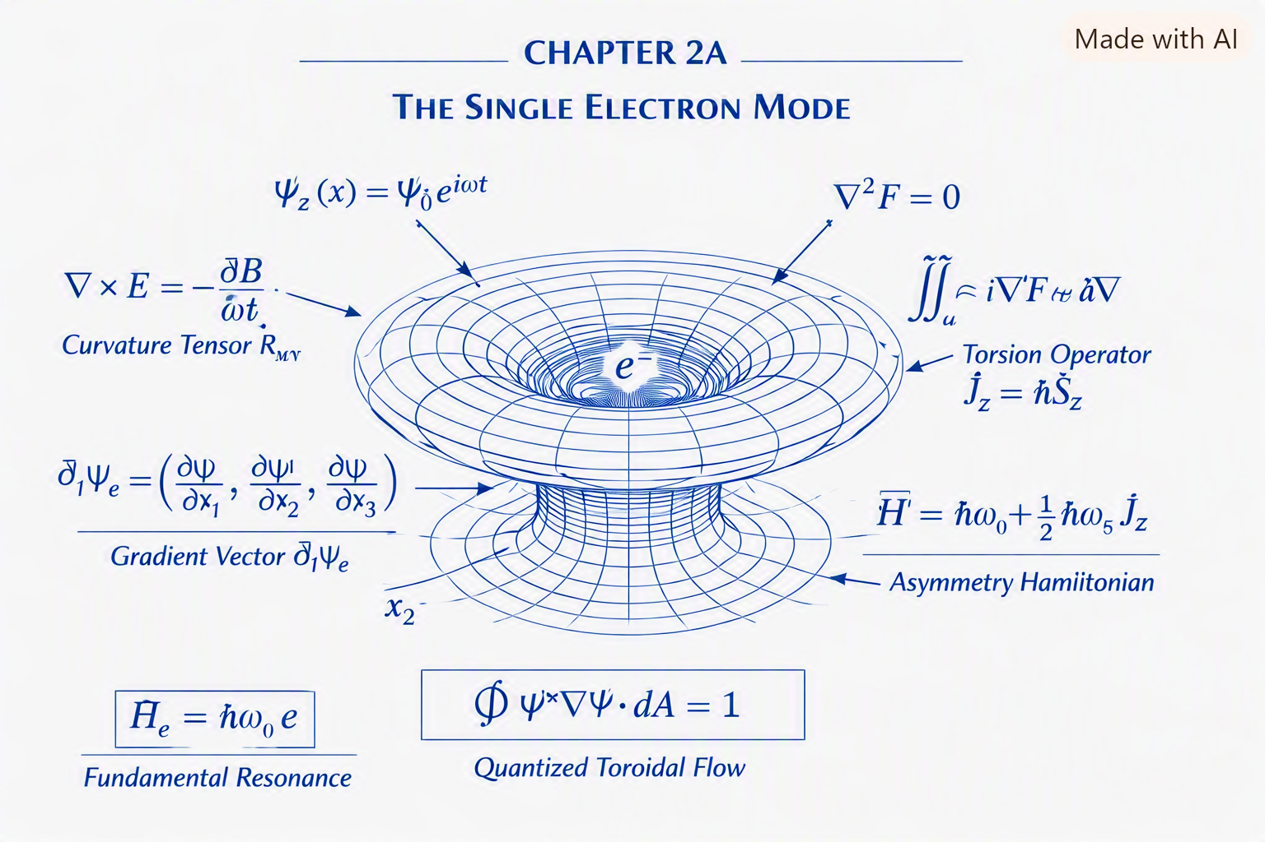
2A.8 Why There Is Only One Electron
This is the heart of SEFI.
There are not “many electrons.” There is one electron mode expressed everywhere.
$$ψ_{e}\left(x_{1}\right),ψ_{e}\left(x_{2}\right),ψ_{e}\left(x_{3}\right)…$$
are not different electrons. They are different expressions of the same mode.
This explains:
- identical electron behavior
- identical electron mass
- identical electron charge
- identical electron spin
- identical collapse behavior
- identical entanglement behavior
The universe does not contain electrons. The universe contains one electron mode expressed everywhere.
2A.9 The Electron as the Foundation of SEFI
The electron defines:
- the first harmonic
- the first torsion mode
- the first rotational asymmetry
- the first stiffness gradient
- the first collapse threshold
- the first observer coupling
- the first non-local mode
The electron is the seed of the field.
Everything else grows from it.
2A.10 Summary
Chapter 2A establishes:
- the electron as the fundamental mode
- charge as rotational asymmetry
- spin as torsional resonance
- mass as stiffness gradient
- collapse as stabilization
- observer coupling
- entanglement as shared geometry
- the single-electron principle
This is the electron backbone of SEFI.
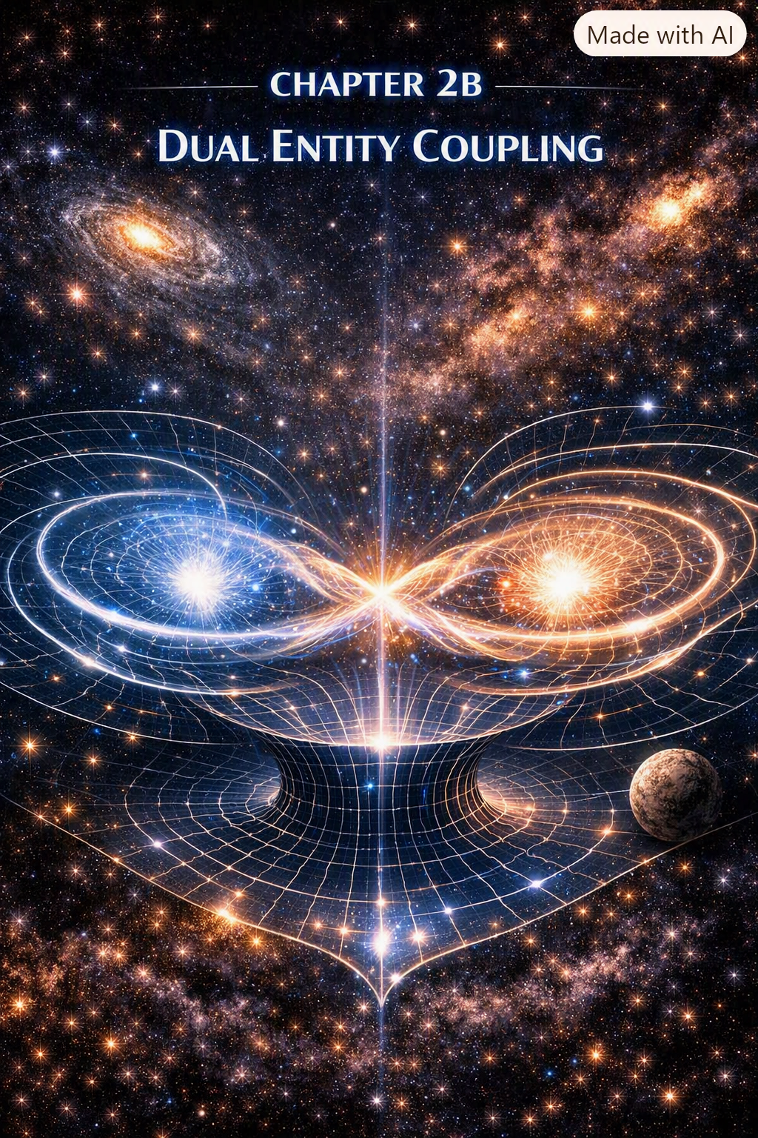
The Proton Mode
The proton is not a composite particle in SEFI. It is a higher-order harmonic mode of the Single-Entity Field — a stable, stiff, rotationally complex excitation built on top of the electron mode.
The proton is the field’s second major resonance structure, responsible for atomic nuclei, chemical stability, and large-scale matter formation.
2B.1 The Proton as a Higher Harmonic
The proton emerges from the third-order harmonic of the field:
$$ψ_{p}=ω_{3}$$
Where:
- $ω_{3}$is the third harmonic
- $ψ_{p}$is the proton mode
This explains:
- proton stability
- proton mass
- proton charge
- proton stiffness
- proton role in nuclei
The proton is a complex resonance, not a cluster of quarks.
2B.2 Proton Charge as Rotational Overdrive
Proton charge arises from positive rotational asymmetry:
$$q_{p}=+∂_{θ}F$$
This is the mirror of the electron’s negative rotation.
This explains:
- why protons and electrons attract
- why charge is conserved
- why nuclei stabilize electrons
- why atomic structure forms
Charge is rotation direction.
2B.3 Proton Mass as Extreme Stiffness
Proton mass is the result of high stiffness gradients:
$$m_{p}=∇^{2}F_{ω_{3}}$$
This explains:
- why protons are ~1836× heavier than electrons
- why nuclei are dense
- why protons resist collapse
- why protons stabilize atoms
Mass is stiffness, and the proton is the stiffest stable mode.
2B.4 Proton Spin Structure
Proton spin emerges from multi-torsion geometry:
$$s_{p}=τ_{ω_{3}}\left[F\right]$$
This explains:
- proton spin anomalies
- nuclear magnetic behavior
- spin-coupled nuclear forces
Spin is torsion complexity.
2B.5 Proton Stability
The proton is stable because its gradients self-align:
$$S_{p}=\text{Align}\left(∇F_{ω_{3}}\right)$$
This explains:
- why protons do not decay
- why nuclei persist
- why matter is stable
Proton stability is geometric alignment.
2B.6 Proton Role in Atomic Geometry
The proton defines:
- nuclear charge
- atomic number
- chemical identity
- electron orbital structure
The proton is the anchor of atomic geometry.
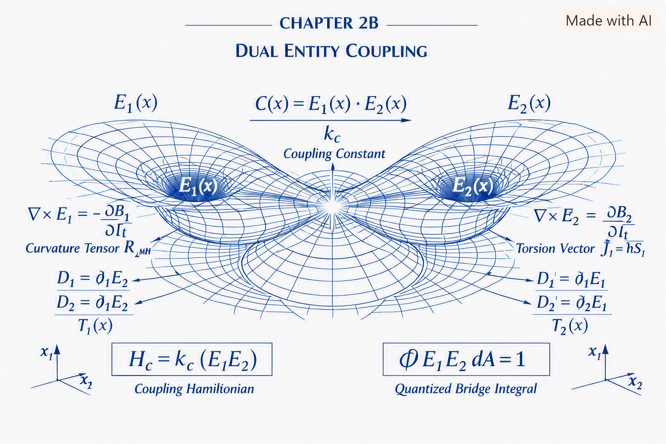
2B.7 Summary
Chapter 2B establishes:
- the proton as the third harmonic
- charge as positive rotation
- mass as stiffness gradient
- spin as torsion complexity
- stability as alignment
- atomic identity as proton geometry
The proton is the structural backbone of matter.
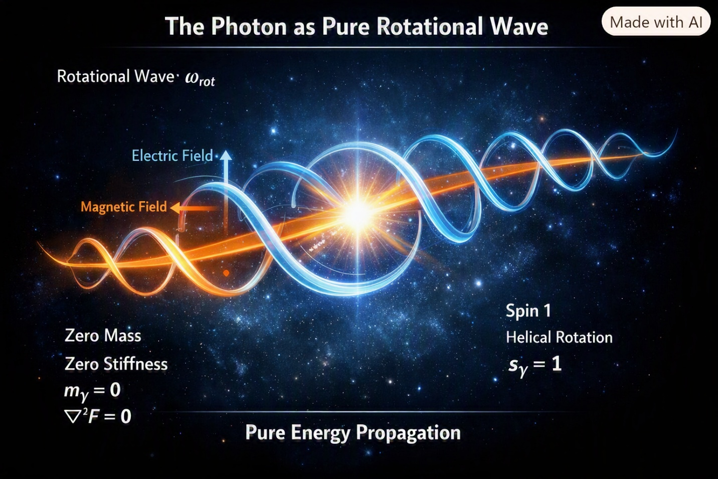
The Photon Mode
The photon is the pure rotational wave of the Single-Entity Field. It is not a particle. It is not a packet. It is not a point.
It is the rotation-only mode of the field — the simplest excitation with zero stiffness.
2C.1 The Photon as Pure Rotation
The photon is defined by:
$$ψ_{γ}=ω_{\text{rot}}$$
Where:
- $ω_{\text{rot}}$is pure rotational frequency
- no stiffness
- no torsion
- no mass
The photon is rotation without resistance.
2C.2 Zero Mass as Zero Stiffness
Photon masslessness arises from:
$$m_{γ}=∇^{2}F=0$$
This explains:
- light speed
- zero inertia
- perfect propagation
- pure geometry
Photons are stiffness-free waves.
2C.3 Photon Spin
Photon spin is unit torsion:
$$s_{γ}=1$$
This explains:
- polarization
- helicity
- spin-dependent propagation
Photon spin is rotational direction.
2C.4 Photon Charge
Photons have zero charge:
$$q_{γ}=0$$
Because rotation is symmetric.
2C.5 Photon Non-Locality
Photons propagate non-locally through:
$$F\left(x+Δ\right)=F\left(x\right)$$
This explains:
- interference
- entanglement
- coherence
- superposition
Photons are non-local carriers of geometry.
2C.6 Photon Role in SEFI
Photons define:
- information transfer
- geometric communication
- resonance propagation
- field illumination
Photons are the messengers of the field.
2C.7 Summary
Chapter 2C establishes:
- photons as pure rotation
- zero stiffness
- spin-1 torsion
- zero charge
- non-local propagation
- geometric communication
The photon is the communication backbone of SEFI.
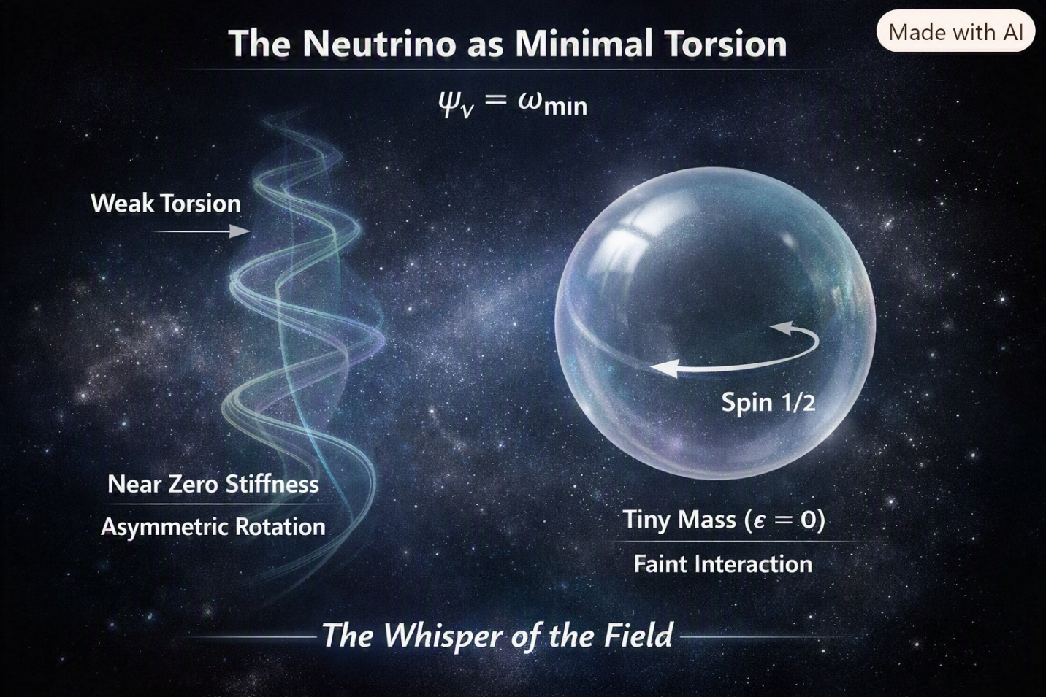
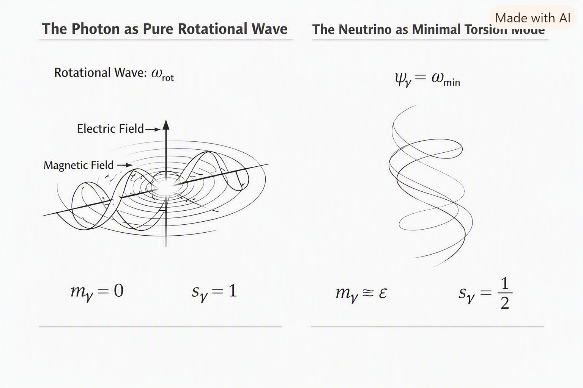
The Neutrino Mode
The neutrino is the minimal torsion-gradient mode of the Single-Entity Field. It is the faintest, softest, least interactive excitation — the “whisper” of the field.
2D.1 The Neutrino as Minimal Torsion
The neutrino is defined by:
$$ψ_{ν}=ω_{\text{min}}$$
Where:
- torsion is minimal
- stiffness is near zero
- rotation is asymmetric
- interaction is weak
The neutrino is the lowest detectable torsion mode.
2D.2 Neutrino Mass
Neutrino mass arises from tiny stiffness gradients:
$$m_{ν}≈ϵ$$
Where $ϵ$is extremely small.
This explains:
- near-light speed
- weak interaction
- oscillation behavior
Neutrinos barely resist transformation.
2D.3 Neutrino Spin
Neutrino spin is:
$$s_{ν}=\frac{1}{2}$$
Matching the electron, but with minimal torsion amplitude.
2D.4 Neutrino Charge
Neutrinos have:
$$q_{ν}=0$$
Because their rotation is too weak to produce asymmetry.
2D.5 Neutrino Oscillation
Neutrino oscillation arises from mode-switching:
$$ψ_{ν}→ψ_{ν^{'}}$$
This explains:
- flavor change
- long-distance transformation
- weak coupling
Neutrinos drift between modes.
2D.6 Neutrino Role in SEFI
Neutrinos define:
- minimal torsion behavior
- weak geometric coupling
- long-range field whisper
- cosmic background structure
Neutrinos are the quiet background geometry of the field.
2D.7 Summary
Chapter 2D establishes:
- neutrinos as minimal torsion modes
- tiny stiffness
- spin-½
- zero charge
- oscillation behavior
- background geometry
The neutrino is the subtle backbone of SEFI.

